

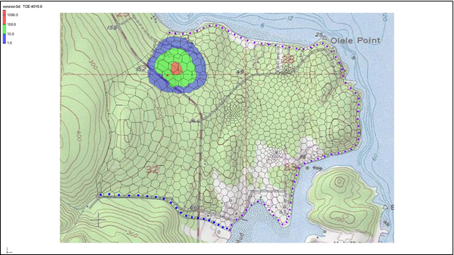

GMS 10.9

GMS 10.9 Tutorial

***MODFLOW-USG Transport – MDT Package 3D Transport***

Use the Matrix Diffusion Transport (MDT) package in GMS to simulate matrix diffusion in a three-dimensional model using a semi-analytic approximation

Objectives

Learn how to use the Matrix Diffusion Transport (MDT) package with MODFLOW-USG Transport to simulate matrix diffusion in a three-dimensional field scale model with an unstructured grid.

Time

* 30–40 minutes

Required Components

* GMS Core
* MODFLOW-USG Transport

Prerequisite Tutorials

* MODFLOW-USG – Complex Stratigraphy
* MODFLOW-USG Transport – Grid Approach

|  |
| --- |
| 1 Introduction 2  2 Getting Started 3  3 Enable MODFLOW-USG Transport 4  4 Defining the BCT Package 5  5 Defining a Prescribed Concentration Source 6  6 Output Control 7  7 Saving and Running MODFLOW-USG Transport 7  8 Examining the Results 8  9 Activating the MDT Package 10  10 Defining the MDT Package 11  11 Adjusting Values in the BCT Package to Fit Conceptual Model 11  12 Saving and Running MODFLOW 12  13 Examining the Results 12  14 Conclusion 15 |

# Introduction

The Matrix Diffusion Transport (MDT) package is compatible with MODFLOW-USG Transport and MODFLOW 6. It enhances existing flow and transport models by incorporating matrix diffusion effects using a semi-analytical method based on the REMChlor-MD model[1], [2], [3]. This simulation capability was developed through a collaboration between Clemson University, GSI Environmental, and Aquaveo, with support from the Department of Defense’s Environmental Security Technology Certification Program (ESTCP).

The MDT matrix diffusion method is conceptually similar to dual-porosity approaches, in which each element is divided into mobile and immobile zones. Solute transport in the mobile zone occurs via advection and dispersion, while transport in the immobile zone occurs solely by diffusion. With MDT, the concentration profile within the immobile zone is dynamically approximated as a function of distance from the mobile/immobile interface. This profile is updated at each time step using the current and previous mobile concentrations, along with the integrated immobile concentration. Mass exchange between the two domains is calculated as a linear, concentration-dependent source term.

This tutorial demonstrates how the MDT package can be applied in a MODFLOW-USG Transport simulation to model diffusion in a three-dimensional heterogeneous porous medium, where heterogeneity exists at the sub-gridblock scale. The example is based on the unstructured grid flow model developed in the MODFLOW-USG – Complex Stratigraphy tutorial, with a hypothetical release of trichloroethylene (TCE) into the aquifer.

For details on the semi-analytic method used in the MDT package, see the REMChlor-MD user’s guide1 and related journal papers2, 3. Input variable descriptions are provided in the MDT package user’s guide[4].

This example uses a five-layer Voronoi UGrid from the “MODFLOW-USG Complex Stratigraphy”tutorialwith the BCT and MDT packages added. The layers are discontinuous and vary in properties, though each layer has uniform properties internally. Sub-gridblock heterogeneities—such as pockets of sand, silt, and clay—exist throughout the domain and cause significant matrix diffusion during contaminant transport.

With the MDT approach, transport is simulated using localized matrix diffusion into and out of the low permeability (low-K) portions of each cell via the semi-analytic method. These low-K zones are not discretely modeled but are represented conceptually using two parameters: the volume fraction of high permeability (high-K) material (VOLFRACMD) and the diffusion length in the low-K material (DIFFLENMD). In this model, advection occurs in only 20% of the cell volume (the high-K fraction), while matrix diffusion occurs into and out of the remaining 80% low-K fraction.

This tutorial will demonstrate the following topics:

1. Opening an existing MODFLOW-USG flow simulation
2. Activating the BCT package
3. Activating the MDT package
4. Running the simulation and examining the results

# Getting Started

Do the following to get started:

1. If necessary, launch GMS.
2. If GMS is already running, select *File |* **New** to ensure that the program settings are restored to their default state.
3. Click **Open**  (or *File |* **Open…**) to bring up the *Open* dialog.
4. Browse to the data files *\MDT_3D\MDT_3D* and select “olele.gpr”.
5. Click **Open** to import the file and close the *Open* dialog.

The Graphics Window should appear as in Figure 1.

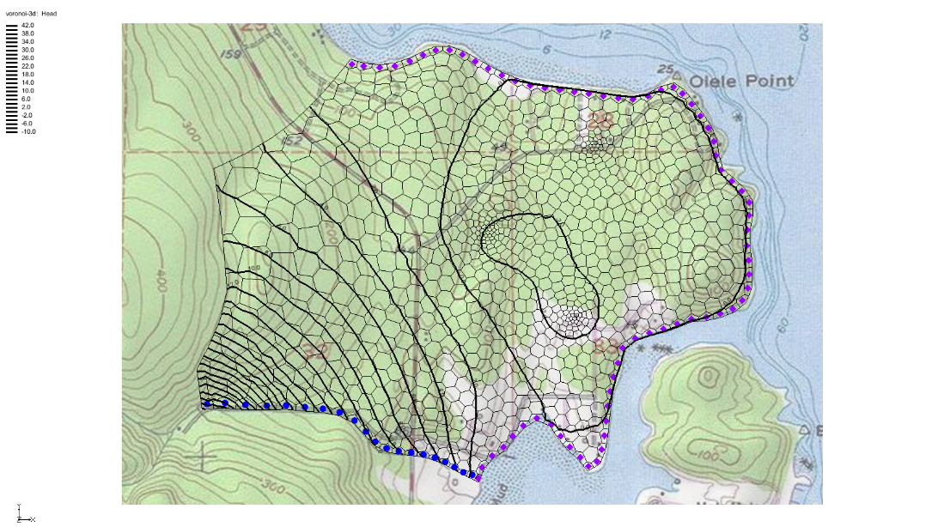

Figure Imported MODFLOW-USG flow model

This model uses a five-layer Voronoi UGrid with local refinement around three pumping wells. General heads boundaries are applied along the coast, with a river boundary on the lower left side. No-flow boundaries represent aquifer thinning on the left and parallel flow in the upper left. The discontinuous layers can be viewed by enabling the *Single layer* option in the *Mini-Grid Toolbar* and toggling through the layers. The 3D grid contains 2,627 elements.

Before continuing, save the project with a new name.

1. Select *File* | **Save As…** to bring up the *Save As* dialog.
2. Enter “olele_transport.gpr” as the *File name*.
3. Select “Project Files (*.gpr)” from the *Save as type* drop-down.
4. Click **Save** to save the project file and close the *Save As* dialog.

# Enable MODFLOW-USG Transport

MODFLOW-USG Transport simulations use the MODFLOW-USG Transport model. To set up this model, complete the following:

1. Switch to the **UGrid**  module.
2. Select *MODFLOW |* **Global Options…** to bring up the *MODFLOW Global/Basic Package* dialog.
3. Under the *MODFLOW version* section, select *USG Transport*.
4. Under the *Model type* section, select *Transient*.
5. Click the **Stress Periods…**button to open the *Stress Periods* dialog*.*
6. Change the *Number of stress periods* to “2”.
7. For the first stress period, set the *Length* to “3650.0” days and the *Num Time Steps* to “20”.
8. For the second stress period, set the *Length* to “32850.0” days and the *Num Time Steps* to “180”.
9. Turn on the *Steady state* option for both time periods.
10. Click **OK** to close the *Stress Periods* dialog.

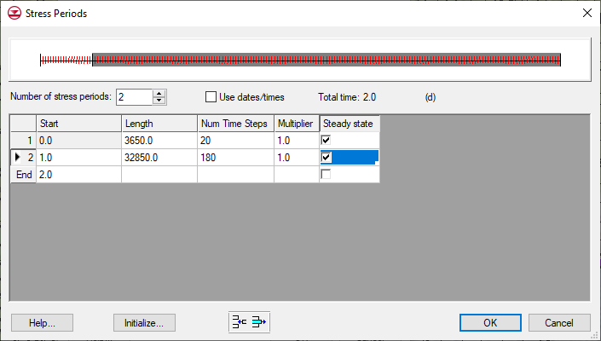

Figure Stress period settings

1. Click the **Packages…** button to open the *MODFLOW Packages / Processes* dialog.
2. In the *Optional packages / processes* section, turn on *BCT – Block Centered Transport* and *PCB – Prescribed Concentration.*
3. Click **OK** to exit the *MODFLOW Packages / Processes* dialog.
4. Click **OK** to exit the *MODFLOW Global/Basic Package* dialog.
5. Click **Yes** when the warning appears about switching to USG Transport.

# Defining the BCT Package

The parameters for the BCT transport package can now be defined.

1. Select *MODFLOW | Optional Packages* | **BCT – Block Centered Transport…** to bring up the *BCT Process* dialog.
2. From the list on the left, select *Variables*.
3. Enlarge the *BCT Process* dialog and enter the following:
   1. *Adsorption (IADSORB)*: “Linear adsorption (1)”.
   2. *Dispersion formula (IDISP)*: “Isotropic dispersion (1)”.
4. From the list on the left, select *Species.*
5. Enter “TCE” under *Species Name*.
6. From the list on the left, select *Aquifer Properties*.
7. Enter the following values in the *Constant Value* column:
8. PRSITY: “0.08”. This is the effective porosity for transport, calculated as 0.4 × 0.2 = 0.08 based on 20% high-K flow in a material with 0.4 total porosity.
9. BULKD: “1.6”. This is the dry bulk density value used for adsorption.
10. DL: “20”. This is the longitudinal dispersivity.
11. From the list on the left, select *Species Properties.*
12. Enter the following value in the *Constant Value* column:
    1. *ADSORB*: “0.05”. Kd value for TCE; this value will give a retardation factor R = 2.
13. Click **OK** to close the *BCT Process* dialog.
14. Select *Edit |* **Units…** to open the *Units* dialog.
15. Set the *Concentration* units to “ppb”.
16. Click **OK** to close the *Units* dialog.

# Defining a Prescribed Concentration Source

To impose a time-dependent prescribed concentration of TCE in a single cell in grid layer 1:

1. Using the **Select Cells**  tool, select cell 886 as shown in Figure 3.

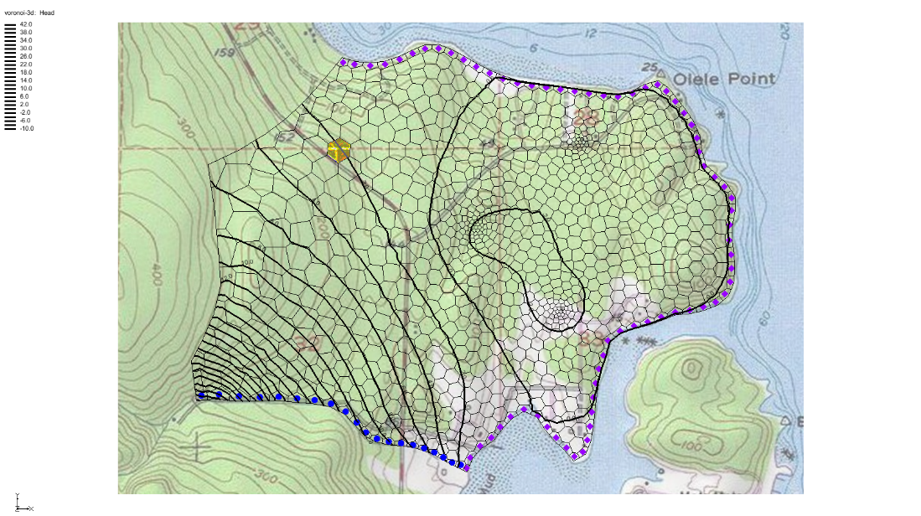

Figure Select cell 886 in layer 1

1. Right-click on the cell and select **Sources/Sinks…** to open the *MODFLOW Source/Sinks* dialog.
2. From the list on the left, select *Concentration (PCB)*.
3. Click **Add BC** to add an entry to the table.
4. Under *Concentration ppb*, in the *886* row, click the  to open the *XY Series Editor*.
5. In row 1 of the *Concentration ppb* column, enter a value of “1000.0”.
6. In row 2 of the *Concentration ppb* column, enter a value of “1.0”.

This sets the TCE concentration in cell 886 to 1000 µg/L for 10 years, then reduces it to   
1 µg/L for the remaining 90 years of the simulation, simulating a contaminant source that is largely removed after the first 10 years.

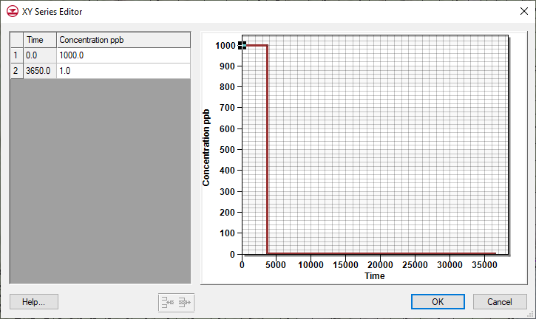

Figure 4 XY Series Editor dialog

1. Click **OK** to exit the *XY Series Editor*.
2. Click **OK** to exit *MODFLOW Sources/Sinks* dialog.
3. Click anywhere outside the grid to unselect cell 886.

# Output Control

To specify the output options:

1. Select *MODFLOW* | **OC – Output Control…** to open the *MODFLOW* *Output Control* dialog.
2. Turn on the *Save concentrations to *.con file* option.
3. Click **OK** to exit the *MODFLOW* *Output Control* dialog.

# Saving and Running MODFLOW-USG Transport

The changes should now be saved before running MODFLOW-USG Transport.

1. Click **Save**  to save the project.
2. Click the **Run MODFLOW**  macro in the toolbar to bring up the *MODFLOW* model wrapper dialog.
3. When MODFLOW finishes, check on the *Read solution on exit* and *Turn on contours (if not on already)* boxes.
4. Click **Close** to close the *MODFLOW* model wrapper dialog.
5. Click **Save**  to save the project with the new solution.

The solution set should appear in the Project Explorer.

# Examining the Results

To make some adjustments to improve the appearance of the TCE contours:

1. In the Project Explorer, select the “ TCE” dataset to make it active.
2. Click the **Display Options**  macro to open the *Display Options* dialog.
3. Click **Options…** next to *Face contours* to open the *Dataset Contour Options – UGrid – TCE* dialog.
4. From the drop-downs in the *Contour method* section, select “Color Fill and Linear” and “Use color ramp”.
5. Click the **Color Ramp…** button to open the *Choose color ramp* dialog.
6. Underneath *Aquaveo*, select the *Color Ramp Shader* palette.
7. Click **OK** to close the *Choose color ramp* dialog.
8. In the *Data range* section, turn on *Specify a range* and enter a “1.0” for *Min* and “1000.0” for *Max*.
9. Turn off the *Fill below* and *Fill above* boxes.
10. In the *Contour interval* section, select “Specified Values” from the drop-down and enter “3”.
11. Turn off the *Fill continuous color range* option.
12. In the *End Value* column, enter “10.0” for row *1* and enter “100.0” for row *2*.
13. Click **OK** to exit the *Dataset Contour Options* *– UGrid – TCE* dialog.
14. Click **OK** to exit the *Display Options* dialog.
15. In the *Time Steps* Window near the bottom left, select the “10950.0” time step.

This view shows conditions 20 years after source removal. The contour plots for layers 1 and 5 should resemble Figure 5 and Figure 6, with plume discharging to the ocean and migrating toward two extraction wells screened in layer 5.

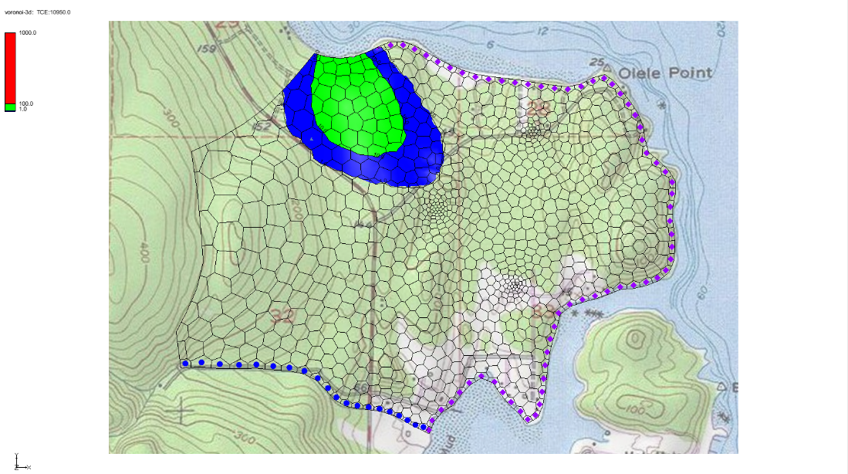

Figure 5 Simulated TCE plume in layer 1 after 10,950 days without matrix diffusion

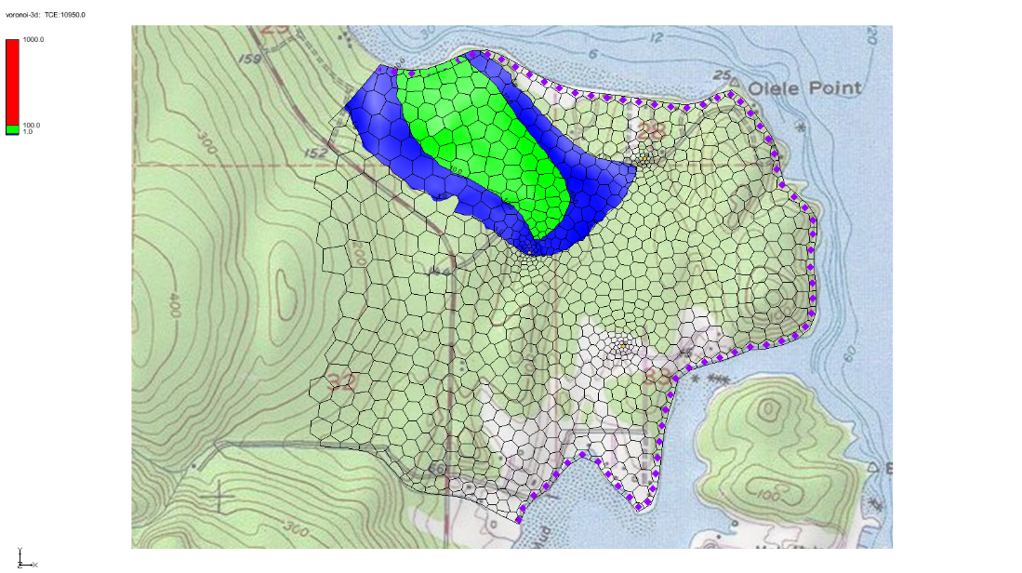

Figure 6 Simulated TCE plume in layer 5 after 10,950 days without matrix diffusion

1. Using the **Select Cells**  tool, select cell 840 in layer 1 as in Figure 7.

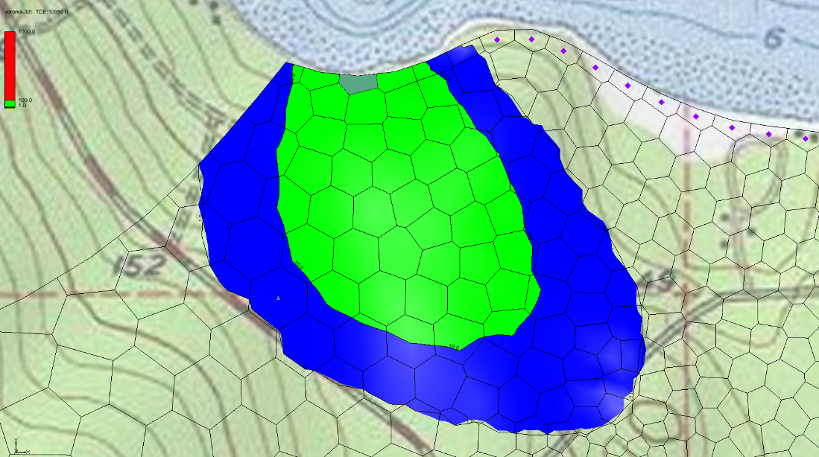

Figure 7 Select cell 840 in layer 1

1. Click the **Plot Wizard**  macro to open the *Plot Wizard* dialog.
2. Under *Plot Type*, select the *Active Dataset Time Series* option.
3. Click **Finish** to close the *Plot Wizard* dialog and generate the plot.

The *Active Dataset Time Series* plot should appear similar to Figure 8.

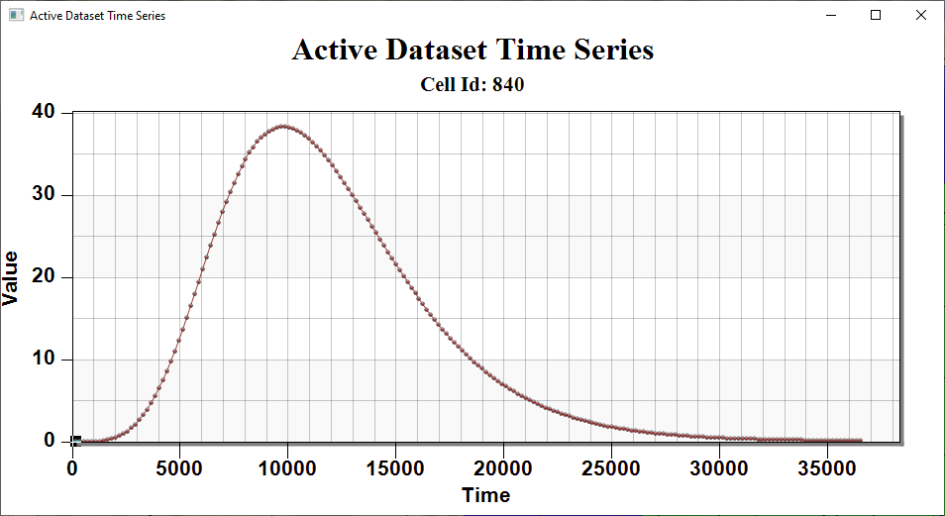

Figure 8 The Active Dataset Time Series for cell 840

# Activating the MDT Package

Before continuing, save the project.

1. Click **Save**  to save the project.

To activate the MDT package:

Select *MODFLOW |* **Global Options…** to bring up the *MODFLOW Global/Basic Package* dialog.

Click **Packages…** to bring up the *MODFLOW Packages / Processes* dialog.

In the *Optional packages / processes* section, turn on *MDT – Matrix Diffusion Transport*.

Click **OK** to exit the *MODFLOW Packages / Processes* dialog.

Click **OK** to exit the *MODFLOW Global/Basic Package* dialog.

# Defining the MDT Package

With the MDT package activated, the parameters for the MDT package can now be defined.

1. Select *MODFLOW | Optional Packages* | **MDT – Matrix Diffusion Transport…** to bring up the *MDT Package* dialog.
2. From the list on the left, select *Variables*.

Review the options here. For this example, the default settings will be used.

1. From the list on the left, select *Aquifer Properties*.
2. Enter the following values in the *Constant Value* column:
   1. *MDFLAG*: “2.0”. Enables matrix diffusion into finite low-K zones within each cell.
   2. *VOLFRACMD*: “0.2”. Fraction of cell volume that is high permeability (high-K).
   3. *PORMD*: “0.4”. Porosity of the low permeability (low-K) material.
   4. *RHOBMD*: “1.6”. Dry bulk density of the low-K material.
   5. *DIFFLENMD*: “1.64”. Diffusion length in the low-K material (converted from 0.5 meters to feet).
   6. *TORTMD*: “0.3”. Tortuosity of the low-K material.
3. From the list on the left, select *Species Properties*.
4. Enter the following in the *Constant Value* column:
   1. *KDMD*: “0.25”. Kd value for the low-K material, selected to give a retardation factor R = 2.
   2. *DIFFMD*: “9.3e-4”. The TCE diffusion coefficient (ft2/d) is due to the choice of units in this model.
5. Click **OK** to close the *MDT Package* dialog.

# Adjusting Values in the BCT Package to Fit Conceptual Model

The BCT package defines transport properties for the high-K zone, which occupies 20% of each cell when the VOLFRACMD parameter is set to 0.2. Adjust the porosity and Kd values in the BCT package to match the conditions used in the previous simulation without matrix diffusion.

1. Select *MODFLOW | Optional Packages* | **BCT – Block Centered Transport…** to bring up the *BCT Process* dialog.
2. From the list on the left, select *Aquifer Properties*.
3. Enter the following value:
   1. *PRSITY*: “0.4”. This is the porosity of the high-K material. With VOLFRACMD = 0.2, it gives the same effective porosity (0.08) used in the previous simulation without matrix diffusion.
4. From the list on the left, select *Species Properties.*
5. Enter the following value:
   1. *ADSORB*: “0.25”. This is the Kd value for TCE that gives a retardation factor R = 2 with a porosity of 0.4, matching the previous simulation without matrix diffusion.
6. Click **OK** to close the *BCT Process* dialog.

With the revised transport parameters, this model will match the previous one without matrix diffusion if the MDT diffusion coefficient is set to a very small (non-zero) value.

# Saving and Running MODFLOW

The changes should now be saved before running MODFLOW-USG Transport.

1. Click **Save**  to save the project.
2. Click the **Run MODFLOW**  macro in the toolbar to bring up the *MODFLOW* model wrapper dialog.
3. When MODFLOW finishes, check on the *Read solution on exit* and *Turn on contours (if not on already)* boxes.
4. Click **Close** to close the *MODFLOW* model wrapper dialog.
5. Click **Save**  to save the project with the new solution.

The solution set should appear in the Project Explorer.

# Examining the Results

To examine the results, complete the following:

1. In the Project Explorer, select the “ TCE” dataset to make it active.
2. In the *Time Steps* Window, select the “10950.0” time step.

At 20 years post-source removal, the contour plots should resemble Figure 9 (layer 1) and Figure 10 (layer 5). The plume is discharging to the ocean and migrating toward two extraction wells screened in layer 5.

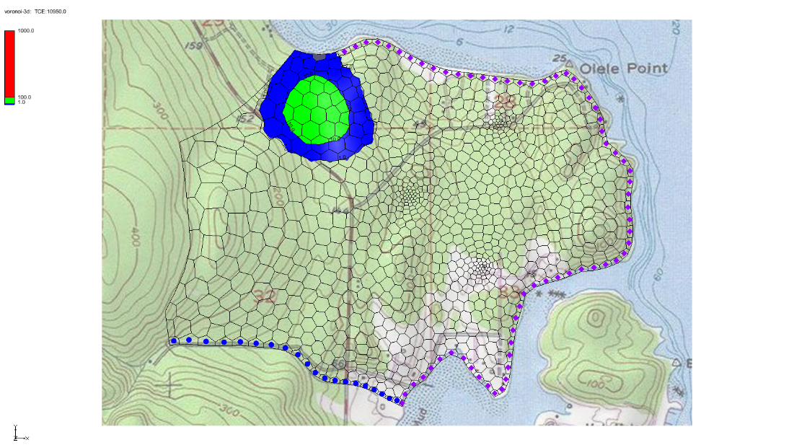

Figure 9 Simulated TCE plume in layer 1 after 10,950 days with matrix diffusion

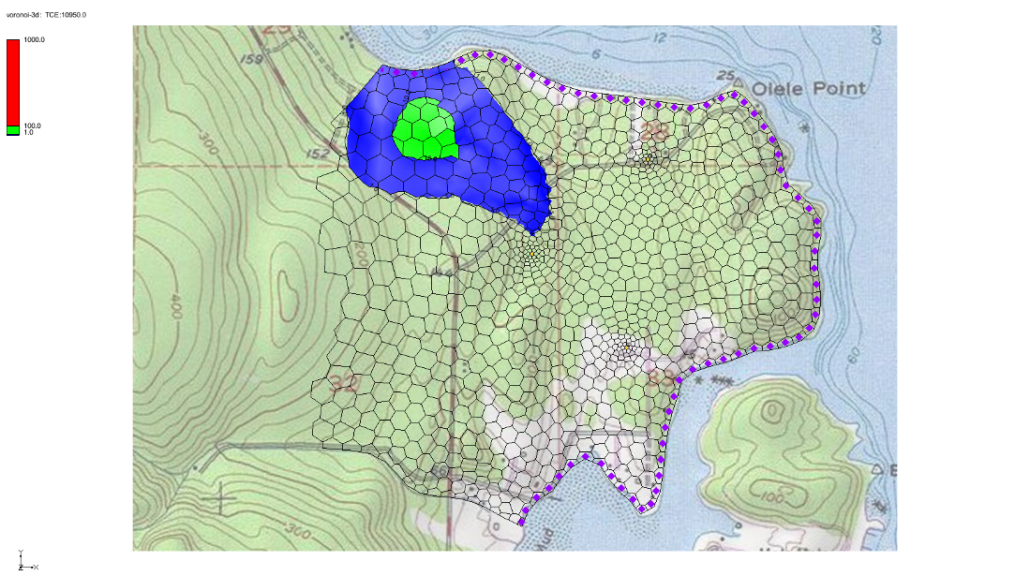

Figure 10 Simulated TCE plume in layer 5 after 10,950 days with matrix diffusion

1. Using the **Select Cells**  tool, select cell 840 in layer 1 as in Figure 11.

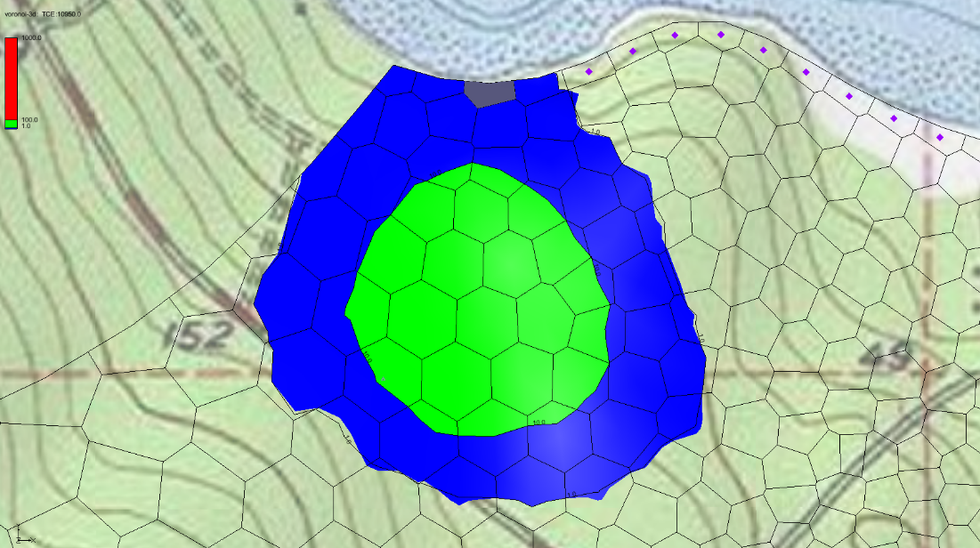

Figure 11 Select cell 840 in layer 1

1. Click the **Plot Wizard**  macro to open the *Plot Wizard* dialog.
2. Under *Plot Type*, select the *Active Dataset Time Series* option.
3. Click **Finish** to close the *Plot Wizard* dialog and generate the plot.

The *Active Dataset Time Series* plot should resemble Figure 12. Note the significant difference from Figure 8, which was generated without matrix diffusion.

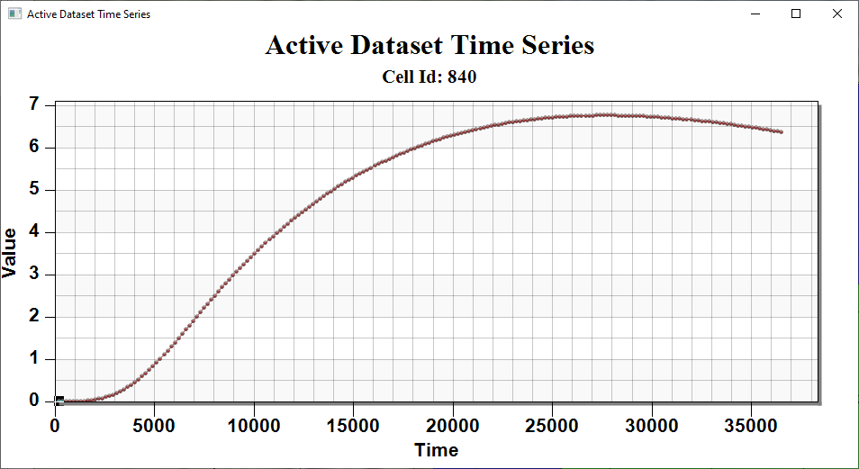

Figure 12 The Active Dataset Time Series for cell 840

# Conclusion

This concludes the tutorial. Here are the key concepts from this tutorial:

* The MODFLOW-USG Transport MDT package simulates matrix diffusion in heterogeneous porous media, especially when diffusion occurs at the sub-gridblock scale.
* The MODFLOW-USG Transport MDT uses standard grid elements, with matrix diffusion represented over a finite distance within each element’s matrix material.

1. Farhat, S. K., Newell, C. J., Falta, R. W., & Lynch, K. (2018). *REMChlor-MD user’s manual*. Clemson University & GSI Environmental Inc. <https://www.serdp-estcp.org/Program-Areas/Environmental-Restoration/Contaminated-Groundwater/Persistent-Contamination/ER-201426>
2. Falta, R. W., & Wang, W. (2017). A semi-analytical method for simulating matrix diffusion in numerical transport models. *Journal of Contaminant Hydrology, 197*, 39–49.
3. Muskus, N., & Falta, R. W. (2018). Semi-analytical method for matrix diffusion in heterogeneous and fractured systems with parent–daughter reactions. *Journal of Contaminant Hydrology, 218*, 94–109.
4. Panday, S., Falta, R.W., Farhat, S., Pham, K., & Lemon, A. (2021*). Matrix Diffusion Transport (MDT) Process for MODFLOW-USG Transport*. GSI Environmental. <https://www.gsienv.com/product/modflow-usg/>